**FRIO COUNTY COMMISSIONERS COURT MINUTES FOR**

**Regular Meeting November 9, 2022**

On the 9TH day of November, 2022, at 3:00 p.m., the Commissioners Court of Frio County met in a regular meeting with the following members either absent or present, to-wit: Arnulfo C. Luna, Frio County Judge was present; Joe Vela, Commissioner Pct 1 absent; Richard “Dicki” Graf, Commissioner Pct 2 present; Raul Carrizales , Commissioner Pct 3 present; Jose Asuncion, Commissioner Pct 4 present; Joseph A. Sindon, Legal Counsel for Frio County Commissioners Court present; and Aaron Ibarra, Frio County Clerk present when the following meeting was held, to-wit:

I. Invocation and Pledge of Allegiance

II. Adopt Agenda

MOTION: RAUL CARRIZALES

SECOND: RICHARD GRAF

MOTION PASSED

III. Old Business

**PRESENTATION**

**ACTION AGENDA ITEMS**

(1) Roxanna Garcia, Frio County Engineer, requests:

1.1 Consider/take action on approving an agreement between Frio County and RDO Equipment Company to install telematics technology on County equipment to allow RDO Equipment Company to view and collect data for the purpose of diagnosing and recommending repairs for County equipment. The telematics technology is proprietary and required to diagnose new equipment.

MOTION: RICHARD GRAF

SECOND: JOSE ASUNCION

MOTION PASSED

2.2 If the agreement is approved, consider/take action on approving a resolution authorizing Hon. Arnulfo C. Luna, Frio County Judge, to enter into same on behalf of Frio County.

(2) Roxana Garcia, Frio County Engineer, requests:

Discussion regarding the progress of construction for the Frio County Building Improvement Project located at 1796 IH 35E, Pearsall, Texas 78061. Sandoval Contracting will be present and provide the update.

(3) Roxana Garcia, Frio County Engineer, requests:

3.1 Consider/take action on approving Change Order #3, Time Extension #2 with Sandoval Contracting for the Frio County Building Improvement Project located at 1796 IH 35E, Pearsall, Texas 78061.

3.2 If the change order is approved, consider/take action on approving a resolution authorizing Hon. Arnulfo C. Luna, Frio County Judge, to enter into same on behalf of Frio County.

(4) Roxana Garcia, Frio County Engineer, requests:

Discuss and approve written notice to Surety Company regarding project progress and potential default.

IV. General Discussion

V. Citizens To Be Heard

*Please note that the Rules of Procedure, Conduct and Decorum at Meetings of the Commissioners Court of Frio County, Texas limit each speaker to a maximum of three (3) minutes to make his or her remarks. Inappropriate conduct or comments during this time, including but not limited to disruptive behavior, insults, personal attacks, and inappropriate language, may result in the speaker being ordered to leave the meeting and forfeit any remaining speaking time. For more information regarding the above-mentioned rules, please see the complete Rules of Procedure, Conduct and Decorum at Meetings of the Commissioners Court of Frio County, Texas, which is available upon request.*

NONE

VI. New Business

**PRESENTATION**

(1) Ronald Rocha, Attorney at Law, Linebarger Goggan Blair & Sampson, LLP**,** requests:

Update on the delinquent fines and collection services by Linebarger Goggan Blair & Sampson LLP.

(2) Roxanna Garcia, Frio County Engineer, requests:

Introduce Mr. Christopher Martin, Chief Operating Officer for Derby Water Supply.

**ACTION AGENDA ITEMS**

(1) Hon. Arnulfo C. Luna, Frio County Judge, requests:

Consider/take action on placing an advertisement in the Frio Nueces Current and all other available sources for a Social Services Clerk to replace Sara Pichardo.

MOTION: RAUL CARRIZALES

SECOND: RICHARD GRAF

MOTION PASSED

(2) Hon. Jose Asuncion, Frio County Commissioner, Precinct No. 4, requests:

2.1 Consider/take action on approving an Agreement for the Provision of Outreach and Enrollment Services between Frio County and South Texas Rural Health Services for the provision of services enrollment services that used to be provided by Sara Pichardo.

2.2 If the agreement is approved, consider/take action on signing a resolution authorizing Hon. Arnulfo C. Luna, Frio County Judge to enter into same on behalf of Frio County.

(3) Hon. Crystal Marquez, Frio County Auditor, requests:

Consider / take action on the acceptance of donated funds totaling the amount of $1,500.00 from Tijerina Towing and Telles Towing & Tire Services to the Frio County Sheriff’s Office.

MOTION: RICHARD GRAF

SECOND: RAUL CARRIZALES

MOTION PASSED

(4) Hon. Crystal Marquez, Frio County Auditor, requests:

4.1 Consider / take action to approve the budget amendments to the FISCAL YEAR 2022-2023 Frio County Budget, list below:

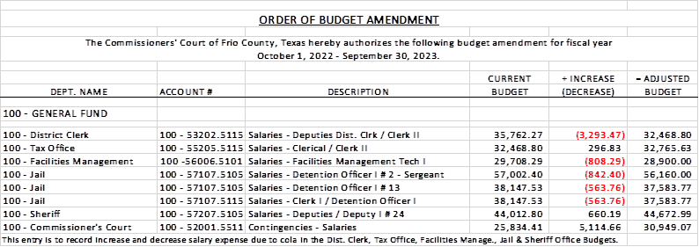

4.2 If the amendment is approved, consider/take action on signing order stating same.

MOTION: RAUL CARRIZALES

SECOND: RICHARD GRAF

MOTION PASSED

(5) Hon. Crystal Marquez, Frio County Auditor, requests:

5.1 Consider / take action to approve the budget amendments to the FISCAL YEAR 2022-2023 Frio County Budget, list below:

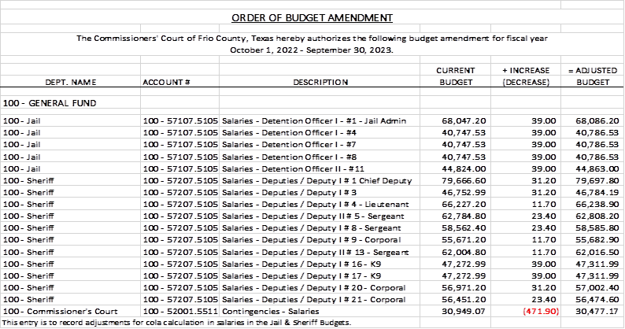

5.2 If the amendment is approved, consider/take action on signing order stating same.

MOTION: RAUL CARRIZALES

SECOND: RICHARD GRAF

MOTION PASSED

(6) Hon. Crystal Marquez, Frio County Auditor, requests:

6.1 Consider / take action on approving Amendment Number 1 to the original contract between Frio County and Kofile Technologies Inc., dated October 13, 2020.  Amendment Number 1 will extend the original contract through October 13, 2026 for an additional cost of $46,494.44.

MOTION: RAUL CARRIZALES

SECOND: JOSE ASUNCION

MOTION PASSED

6.2 If the amendment is approved, consider/take action on signing a resolution authorizing Hon. Arnulfo C. Luna, Frio County Judge to enter into same on behalf of Frio County.

(7) Hon. Crystal Marquez, Frio County Auditor, requests:

Consider / take action on approving payment for indigent cremation for James Brown to Trevino Royal Oaks Funeral Chapels.

MOTION: RAUL CARRIZALES

SECOND: RICHARD GRAF

MOTION PASSED

(8) Hon. Crystal Marquez, Frio County Auditor, requests:

Discuss / take action on refunding Mary Moore for uncompleted requested voter data information for a total amount of $1,649.00, and determine which budget to issue the refund.

(9) Roxana Garcia, P.E., Frio County Engineer, requests:

discuss the approved 2020-2021 Frio County Pay Scale and Road & Bridge Minimum Pay Grade for Road Technician II.

(10) Hon. Crystal Marquez, Frio County Auditor, requests:

10.1 Consider / take action to approve the budget amendments to the FISCAL YEAR 2022-2023 Frio County Budget, list below:

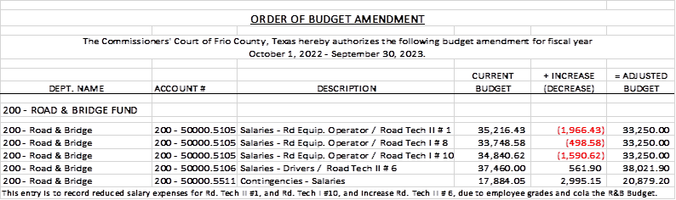

10.2 If the amendment is approved, consider/take action on signing order stating same.

(11) Roxana Garcia, P.E., Frio County Engineer, requests:

Discussion and update on the survey performed by Howland Engineering and Surveying Company and the construction of the Derby, TX county roads (eastside).

(12) Frio County Commissioners Court, requests:

12.1 Consider/take action on approving an Interlocal Agreement between Frio County and the cities of Pearsall and Dilley, and the Pearsall Independent School District for the provision of emergency medical services within those jurisdictions.

MOTION: RAUL CARRIZALES

SECOND: RICHARD GRAF

MOTION PASSED

12.2 If the agreement is approved, consider/take action on approving a resolution authorizing Hon. Arnulfo C. Luna, Frio County Judge, to enter into same on behalf of Frio County.

(13) Frio County Commissioners Court, requests:

Receive in person from the following county officials the following reports as mandated by law:

13.1 Presentation by Frio County Treasurer of detailed report as mandated by Section 114.026, Local Government (“Code”) (this report is to be presented at each **regular term of commissioners court).**

13.2 Frio County Treasurer to exhibit the books and accounts of that office for the inspection of the commissioners court (**to be done at each regular term of commissioners court).**

13.3 Consider/take action on authorizing the execution by Frio County Commissioners Court (the Judge and each commissioner) of an affidavit stating the requirements of the treasurer’s report have been met as mandated by section 114.026 of the Code.

13.4 Consider/take action on execution of an order of the commissioners court approving the county treasurer’s report and order their publication in the Frio-Nueces Current as mandated by Section 114.026 of the Code or publication on the county’s website.

MOTION: RICHARD GRAF

SECOND: RAUL CARRIZALES

MOTION PASSED

(14) Frio County Commissioners Court requests:

Presentation, pursuant to Section 114.044 of the Local Government Code, by:

1. Frio County District Clerk;

2. Frio County Clerk

3. Frio County Treasurer

4. Frio County Attorney

5. Frio County Judge

6. Frio County Sheriff

7. Frio County Auditor

8. Frio County Justice of the Peace

9. Frio County Constables

**(who collects or handles any money for the use of the county) of all fines imposed, judgments rendered and collected, and all jury fees collected by the respected courts in favor of or for the use of the county and at that time when the reports are presented to present receipts vouchers that show disposition of the money, fines or judgments.**

After examination by the commissioners court as to the correctness of the reports, consider/action on directing the county clerk to enter information in county finance records as mandated by Section 114.044 of the Code.

MOTION: RAUL CARRIZALES

SECOND: RICHARD GRAF

MOTION PASSED

(15) Documents (resolutions, orders, contracts, etc.) to be signed.

(16) Allow bills payable

MOTION: RICHARD GRAF

SECOND: RAUL CARRIZALES

MOTION PASSED

(17) Adjourn

MOTION: JOSE ASUNCION

SECOND: RAUL CARRIZALES

MOTION PASSED